CRM Project

Functional Specification - Enhancement

PP6

(PP6) CM-090-150-160-E CM_ENH_290 Contract Mgt End Contract & Meter Data

Deliverable Name | (PP6) CM-090-150-160-E CM_ENH_290Contract Mgt End Contract & Meter Data
Date | 11/11/2010
Revision | V1.0
Signed off By | Functional lead/PP6 Owner
Signoff Date

TABLE OF CONTENTS

1. Version 3
2. Approvals 3
3. Priority Mention the Priority of the object from the FRICEW list in ILM. Processing Mode (check all that apply) 3
Low Medium High 3
4. Enhancement Requirements Description 4
5. Impacted Systems 4
6. Approach to be followed < List the type of enhancement whether it is a user exit, BADI or Custom transaction> 4
7. Roles and Volumes 4
8. Security & Control Requirements 5
8.1. Security Requirements 5
8.2. Control/Audit Requirements 6
9. Dependencies 6
9.1. Development Dependencies 6
9.2. Run/Execution Dependencies 7
9.3. Archiving Dependencies 7
10. Execution Steps 7
10.1. Process Description 7
10.2. Process Flow 7
10.3. As-Is Systems Referred To 8
10.4. Processing Options 8
11. Enhancement Description 8
11.1. Detailed Description of the Enhancement 9
11.1.1. Contract & Meter Data 9
11.2. UI Design and Screen Flow < Mention the WEBUI Design in the sense the mock up screens and the navigation flow between the screens etc> 13
11.3. Access Method or Path for Enhancement 14
11.4. Required Custom Tables (if known) 14
11.5. Error Handling Rules 15
12. Enhancement Reconciliation & Testing Requirements 15
12.1. Data Validation 15
12.2. Testing Reconciliation 15
12.3. Performance Issues 15
13. Additional Information 15
14. Open Items 15
15. Functional Unit Test cases <Here they should list the possible test scenarios in the table below> 15

Version
Ensure that any approved change requests that affect scope are documented in the revision history and include CR #.
Version | Change Description | Author | Date Released | Sections Impacted
Enter in the version number | Brief description of the change | Who made the change | Date change was made | Mention the sections impacted with this change
1.0 | Creation | J Jarone | 11/11/2010
1.1 | Pre Process Owner Review | J Jarone | 11/16/2010
1.2 | Post Process Owner Review | J Jarone | 11/17/2010
1.3 | Post Development Review | J Jarone | 12/22/2010
2.0 | Limit Tree display to active objects (Premise, Contract, Contract Account, and Business Partner. – Item 11.1.1.1.1, page 10  Cancel Process message verbiage – Item 11.1.1.3, page 12 | J Jarone | 02/07/2011 | Section 11.1
3.0 | Change Request (CHG04166): Updated 11.1.1.2.1 Page-11 Meter Data View: Contract End Date needs to determine the Meter Read Date  Change Request (CHG4160): Updated 11.1.1.2.1 Page-11 Meter Data View: Remove Release Button  Change request (CHG04061): Updated 11.1.1.1 Page 9 and 11 Contract Details: Remove hyperlinks | Sanjeev Singh | 08/01/2011 | Section 11.1
3.1 | Change Request CHG04352  Only Business Center business role can perform an End Contract for a Business Center Customer | J Jarone | 10/18/2011 | Section 11.5

Approvals
The individuals listed below will be required to review and approve this document.
Reviewers Title | Reviewer Role | Name
Project Title of Reviewer | Reviewer's Role (Responsible, Approve, Consult, Inform) | Reviewer's Name

Priority
Mention the Priority of the object from the FRICEW list in ILM.
Processing Mode (check all that apply)

Low Medium High

Enhancement Requirements Description
<This section should contain a detailed description of the business requirements for this enhancement in business terms. Please insert any description of the business flow which would aid in understanding this process.>
This enhancement is one of 4 sub process to be developed within the End Contract process framework. The processes are as follows, Contract & Meter Data, Notifications, Address Maintenance, Summary, figure 4.1. This enhancement, Contract & Meter Data, will require input from the Pre Move-In development and will export information required in subsequent steps within the process framework.

The user will provide the Contract End Date and, if available, final billing meter reads within this view set.

Figure 4.1

Impacted Systems
<This list should include systems that are being impacted as a result of this enhancement.>
CRM 7.0 Web IC : CRM 7.0 Web Client Interaction Center Production System
ECC 6.0 / IS-U ECC 6.0 / IS-U - Back End Production System (Enterprise Central Component)

Approach to be followed
< List the type of enhancement whether it is a user exit, BADI or Custom transaction>
Custom Transaction

Roles and Volumes
<Describe information regarding users and volumes. Make sure to note if the use of this development will require additional communication and/or training. Also, specify what the volume requirements will be needed by the Go-Live date.

Complete the table below with the correct project-specific information for this functional specification. Instructions are in the middle row, and a sample entry is in the bottom row.>

Role | Estimated Volume Requirement | Comments
List name of role; should come from the list of security roles | Enter the estimated volume requirements that will be needed by the Go-Live date | Enter other comments including if this development will require additional communication and/or training
CSR 2 | 1500 per day
CSR 3 | 1500 per day
CSR 4 | 25 per day
VCC MGMT | 25 per day
BCOS | +- 75 per day
Billing | +- 75 per day
Consumer Affairs | +- 75 per day
Revenue Recovery | +- 75 per day

Security & Control Requirements

Security Requirements
<Describe any security requirements that need to be put in place as a result of this development object. This could include security access to affected transactions or new transactions that may result from this development. If the enhancement has to be archive enabled, list additional security to be added to the roles.>

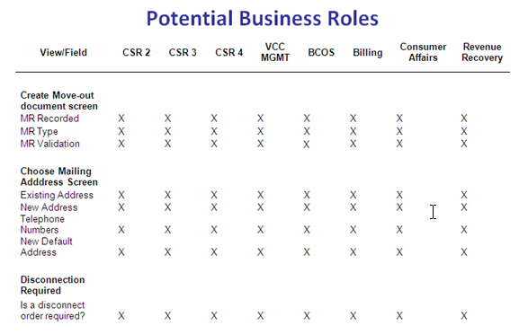
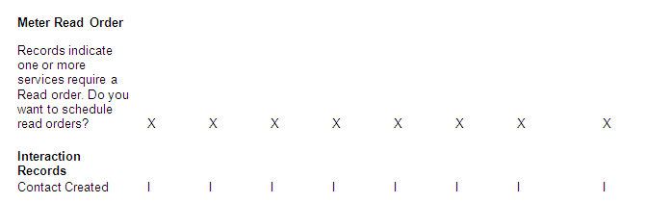
Figure 8.1.1

Security requirements will be handled through business roles. The business roles in figure 8.1.1 will have access to the End Contract process framework.

- CM-090-050-010-S Security will be handled through business Roles. The Contract Management work center will be available by business roles.
- CM-090-150-020-S - CSR business roles that perform a move-out on non-owner allocated C&I accounts should be forced to create a disconnect notification

Control/Audit Requirements
<Describe any control requirements that need to be put in place as a result of this development object>.
- If applicable, please answer the question and also provide detail to the question.
- The questions listed below are not all inclusive to the control requirement that may be required. If there are any other controls requirements please document them as well.

- Indicate if this enhancement is being developed to address a control requirement?
- Financial/SOX Impact - Does the enhancement have any impact to financial reporting? If yes, is the amount significant (i.e. greater than $35 million annually)? Please provide an estimate.No
- Regulatory Impact - Does the enhancement have any impact to regulatory compliance (i.e. FERC, NERC, etc)? If yes, please provide a reference to the rule and describe the impact. No
- Operational Impact - Is the enhancement relied upon for a mission critical process or providing services to customers? If yes, please identify the mission critical process and describe how this enhancement is used in the context of this process. Yes, this enhancement provides the ability to End a Business Partners’ contract with Consumer’s Energy.

Dependencies

Development Dependencies
<List the configuration, development, and other work that must be considered during the creation of this enhancement.>

Seq. | Development ID | Change ID | Description
1 | CM_ENH_110 | CM-090-090-070-E | FO_ENH_670_1_Move In_PMI - Contract Mgt Pre-Move In – Technical BOL Tree development is to be re-used in this development
2 | CM_ENH_1170 | CM-050-070-030-E | (PP6) CM-050-70-030-E Enter Meter Read & Perform Corrections (CM_ENH_1770)

Run/Execution Dependencies
<Once in production, this development object may need to be executed before or after another system event. List other system events that this development object should follow or precede. If the enhancement is to be archived enabled, does it need to have adequate archived sessions, info structures, etc established in order to test/execute.>

Business Partner and Premise must be confirmed.

Archiving Dependencies
<List how the changes would impact archiving, if the enhancement impacts existing archived objects (i.e. table structures). Also list what needs to be regression tested from an archiving perspective.>

N/A

Execution Steps
This process may be accessed in two ways:
- A user may click directly on Contract Management Work Center and select the End Contract button
- A user may select the submenu from Contract Management Work Center, and select the End Contract (This will be the Best Practice method)

Process Description
<Explain the process for when this development object will be used. If this is tied back to a certain task within a process you may insert the Task Profile document here as well.

Enter any of the following information available:
- Transaction Code
- User Exits
- Performance Consideration
- Z Tables created
- Code reuse.
New Enhancement / ECC Code reuse

Process Flow
<Create a diagram that visually depicts the process.>
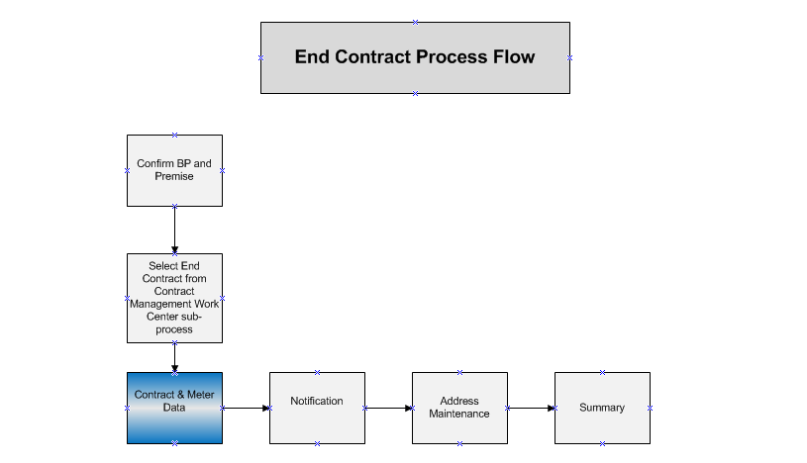

As-Is Systems Referred To
<List the systems that the task pertaining to this development object is performed in. If this is a new task (i.e. not being performed today), list it ‘Not applicable’.>

This task is currently performed in the Move-Out FOP

Processing Options
<Indicate the Processing Mode, Frequency, and Lifetime of Development by selecting and placing an ‘X’ in the box next to the correct options below. Right click on the gray box, select properties, and specify “Checked”.>
Processing Mode (Select one of the following)
Batch Online – via Transaction Code Online – via Menu Path
On demand

Frequency (Select one of the following)
Daily
Weekly Quarterly
Monthly Annually
Other (If other, describe here) On Demand

Lifetime of Development (select one)
Permanent
Temporary, e.g. until rollouts are complete, specify details here

Enhancement Description
<Provide a brief description of the enhancement.>
The End Contact process framework has been broken into individual units of work that must share data when configured as a whole. This development will need provide the data that will be used in subsequent steps in the End Contract Process framework.

This document will describe the enhancement in 3 sections. Section 1 will describe the process of setting the Contract End Date within the Contract Details view area. Section 2 will describe the Meter reading view area and section 3 will describe the Service Environment view area.

Detailed Description of the Enhancement
<Provide a written description of the functionality that needs to be developed. Identify/describe the SAP application transaction that uses or is used to invoke the enhancement. Describe tables, transactions, reports, forms, screens and other objects that need to be created or modified. Insert a Visio flow diagram of the process to be executed by the enhancement, and add any other information required to develop the enhancement.>

Contract & Meter Data
The End Contract process may be accessed only if a Business Partner and Premise have been confirmed. If the user attempts to access the End Contract process by the Contract Management End Contracts sub process or Contract Management work center then display System error message 020 in section 11.5

The Contract & Meter Data view area allows the user to view the contracts and apply the Contract End Date. The user will be able to view the existing product, ECC contract number, and ECC installation number. The contract selection indicator will be marked by default and the user will be able to unmark a contract if desired.

      - Contract Details
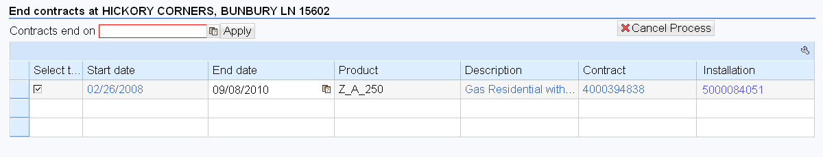

UI Component - IUICCON
View - IUICCON/ContractListEnd

On the Contract Details View, remove the hyper links for all the fields in Contract Details (e.g., Contract, Installation, Product Description and Date). Also End Date is display only and user should not be able to change it. The only way to change end date is through date applied in the Contract End on field.

Display Contract Follow Up Actions / Enhancements
Field | Origin | CRM Save | ECC Save | Follow Up
Contract End Date | User Action | Yes | Yes | Date available for:  CM-090-150-220-E Contract Mgt End Address Maintenance (CM_ENH_300)  CM-090-150-040-E Contract Mgt End Notification  (CM_ENH_1760)  CM-090-150-260-E Contract Mgt End Summary (CM_ENH_280)
Cancel Process | User Action | No | No | Business Role Landing Page should be displayed

        - Cancel Process

If the user decides to cancel the process by selecting the ‘Cancel Process’ button then the standard confirmation dialog popup should be displayed. If the user confirms cancellation then the landing page after account confirmation should be displayed.

If notifications have been create prior to selecting the Cancel Process button then display the follow:

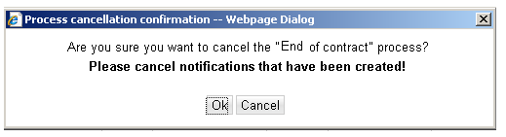

If no notifications have been created display the following:

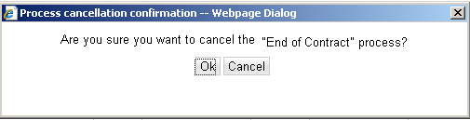

Press CANCEL. The system should remain in the current view.

Press OK. The system should navigate to the BP Identification view

        - Contract End Date
This field will not be defaulted to the system date. The agent will ‘Apply’ the end date for the contacts. System error message 010 in section 11.5 until the user enters the contract end date. Once the date has been added or updated meter reading dates should change as well.

The system should not allow the end date of the contract to overlap with existing contracts. Meaning the end date should not be prior to the start date of the contract. The standard system error messages should be displayed forcing the user to select valid contract end dates. ‘Contract Ends on Date’ field can only be modified by entering a date and then clicking ‘Apply’. The Contract End Date in Contract Details assignment block should be grayed out and it should NOT be available for user to change. It should be Display only.

        - Installation
Display the installation number associated with the POD. Clicking on the installation will not display a new view.

      - Meter Reading

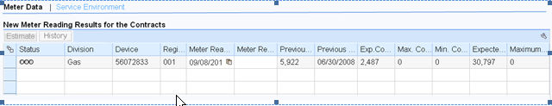
The system will display the Meter Data view by default. The user will use the Meter Data view to enter, estimate, and release meter readings of read reason 03 (Final Bill). The user should be able to display all meter read history for all devices via the existing functionality. The existing view will be enhanced.

UI Component – IUICMRD
View - IUICMRD/MeterReading

        - The Meter Data View
            - Meter Read Date – The meter reading date should change to equal the Contract End Date. User should not be able to change the Meter Read Date. It should always be equal to the Contract End date applied.
            - Meter Read Validation – No change to standard SAP validation
            - Meter Read Estimation – No Change to standard SAP estimation
            - Meter Read Release - Meter Read Release button should NOT be available in the Meter Data View (it needs to be REMOVED).
            - Meter Read History – No Change to the standard SAP.

      - Service Environment View Area
The user will be able to view the CRM Technical Environment. This view will be the same view displayed in CM-090-090-050-EContract Mgt Pre-Move In enhancement (CM_ENH_110). Figure 11.1.1.3.1.

This area provides the user with an overview of the service address to help identify existing conditions at the premise, along with icons which represent the state of the premise (active, inactive, lock, partial lock). Based on the UI Document Potential Business Roles the following fields will be available for the Service Environment tree. –Figure 11.1.1.3.2.
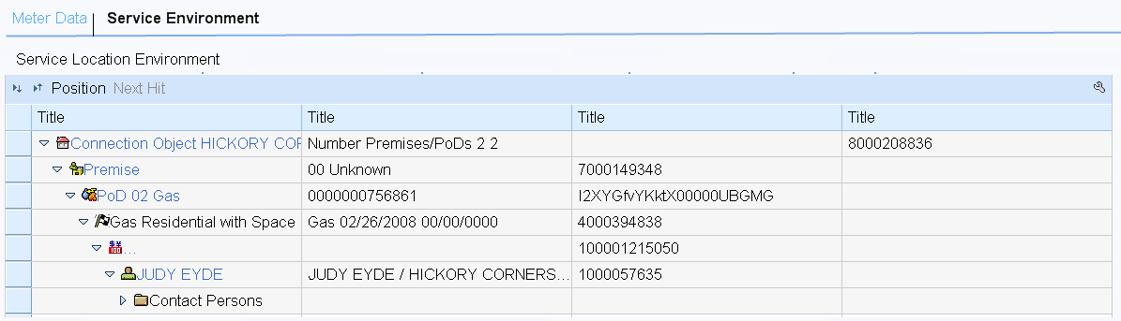
Figure 11.1.1.3.1

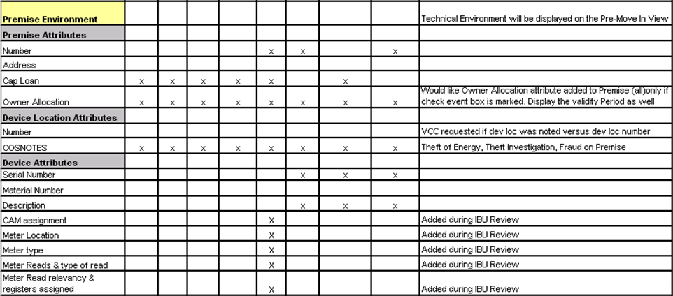
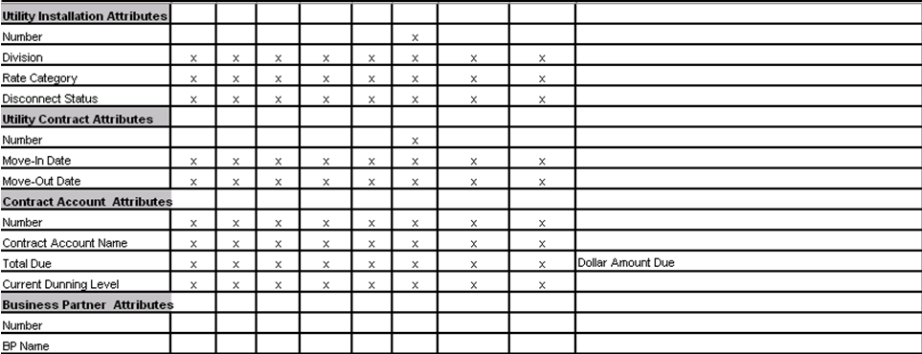
Figure 11.1.1.3.2

Description | Attribute/Table/Field
Premise Number | EVBS - Only the confirmed premise should appear
Premise Address | ZPremises.ZPremAddr
Cap Loan | ZPremises.CAPLoan
Owner Allocation | ZPremises.ZPropertyOnwerAlloc
Dev Loc Number | EGPLD
COSNOTES | ZDeviceLocation.COSNotes
Device Serial Number | IT0B
Material Number | ZDEVICE.MaterialNumber
CAM Assignment
Meter Location | ZDEVICE.ZDevLocDetails
Meter Type | ZDEVICE.DeviceType
Meter Reads and type of read | ZDEVICE.MeterReadingDocument
Meter Read relevancy & registers assigned | ZDEVICE.MeterReadingDocument
Installation Number | EANLD
Division | INSTLN.Division
Rate Category | INSTLN.ActRateCat
Disconnect Status | INSTLN.ZDiscDocStat
Contract Number | EVERD - Only Active Contracts should be displayed
Move In Date | ZUtilContract.MoveInDate
Move Out Date | ZUtilContract.MoveOutDate
Contract Account Number | FKKVKBP - Only the active Business Agreement should appear in the Tree
Contract Account Name | ZUtilAccount.ContractAcctName
Total Due | ZUtilAccount.ZTotalNoFuture
Current Dunning Level | ZUtilAccount.ZDunningLvlCurrCdwLabel
BP Number | BUS_JOEL_MAIN
BP Name | ZUtilBusinessPartner.Name

UI Design and Screen Flow
< Mention the WEBUI Design in the sense the mock up screens and the navigation flow between the screens etc>

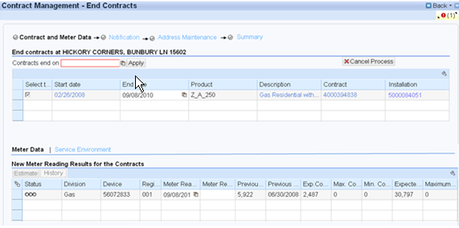

Access Method or Path for Enhancement
<Select the correct execution path below by placing an ‘X’ in the checkbox next to it and completing the description that follows. Check all that apply and add any other execution methods if required by the Client. Right click on the gray box, select properties, and specify “Checked”.>
Execution: Custom Transaction Code:
Menu Path:
Standard Transaction Code:
Other: CRM 7.0 Web IC Navigation

Required Custom Tables (if known)
<Provide any information about custom tables required for this enhancement.>
N/A
Table Name: Enter Table Name
Table Description: Enter Table Description
M/O | Field Description | Type (text or numeric) | Maximum Field Length | Value Restrictions? | Validations?
Mention M if the field is mandatory and O if the field is optional | Enter the field description | Enter the type | Enter the max. field length | Enter any value restrictions | Mention if any validations are required or else mention NA

Error Handling Rules
<Explain what the error handling rules would be if there are any for this development. For example, if an enhancement is scheduled to be printed and it does not, what should a user do to get this corrected?>
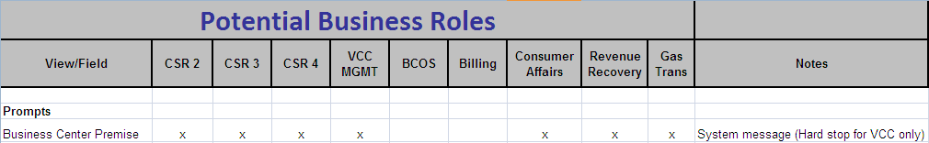

(Note: Use of Pop-ups and Alerts at appropriate events)
Dialogue Pop Ups (Alerts) Displayed Prior to the Presentation of the Contract & Meter Data View – Message to Display | Table
MV90 Alert - If the MRU for the current time slice begins with MV90, warning message  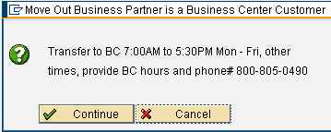 is displayed prior to the presentation of the Contract & Meter Data View. When Continue is chosen the user is taken to the Contract & Meter Data View. If Cancel is chosen the user is returned to the Identification View. | Set the Continue button as the first button, but set the Cancel button as the default button.  Going forward with CRM 7.0 the CSR role will not be allowed to select Continue. This will be a hardstop for the CSR role (refer to the Potential Business Roles (ALERTS) UI document below). Other roles will be allowed to continue.
Business Center Alert - If the business partner is defined as a “Business Center” customer (EKUN- CLASSIFICATION = 01), warning message  is displayed prior to the presentation of the Contract & Meter Data View. When Continue is chosen the user is taken to the Contract & Meter Data View. If Cancel is chosen the user is returned to the Identification View. | Business Center customer = EKUN – CLASSIFICATION = 01  Set the Continue button as the first button, but set the Cancel button as the default button.  Going forward with CRM 7.0 the CSR role will not be allowed to select Continue. This will be a hardstop for the CSR role (refer to the Potential Business Roles (ALERTS) UI document below). Other roles will be allowed to continue.

If no error or warning system messages are displayed in this view the process framework traffic light will be green and the user will be allowed to submit the contract(s) in the summary view.

Msg No | MSG TYPE | CRM 7.0 System Messages to Appear on Product Questionnaire View
010 | Error | Message: Please enter the Contract End Date
020 | Error | Message: Please Confirm BP and Premise

Enhancement Reconciliation & Testing Requirements

Data Validation
Data validation will require the expected test cases execution and verifying the results based on business requirements. CRM project team along with their business support teams will be responsible to ensure this enhancement works.

Testing Reconciliation
This enhancement will be tested by the teams (their security roles) who perform the New Contract process. Teams will include CRM project team, BTS support team, Call Center, BCOS, Revenue Recovery, Consumer Affairs, and Billing.

Performance Issues
N/A

Additional Information
<Enter any additional information that could be helpful in developing this enhancement.>
N/A

Open Items
<This includes Risks and Issues logged in Clarity and Action Items.>
Item # | Detailed Description | Proposed Solution
Insert number | Describe the item | Describe the proposed resolution

Functional Unit Test cases <Here they should list the possible test scenarios in the table below>
Test Condition Description | Input Data | Expected Results | Actual Results/Comments
User attempts to move off of Contract & Meter Data without applying the contract End date. |  | Error: “Please enter the Contract End Date” is displayed
User enters meter reads and then applies the contract end date. |  | Meter reading date modified to equal the contract end date
User applies the contract end date  Enters plausible meter reads. |  | Meter reading date equal the contract end date. Meter reads displayed and plausible
User applies the contract end date  Enters a high meter read |  | Meter reading date equal the contract end date. Meter reads displayed and implausible
User applies the contract end date  Enters a low meter read |  | Meter reading date equal the contract end date. Meter reads displayed and implausible
User applies the contract end date  Estimates meter read |  | Meter reading date equal the contract end date. Meter reads estimated
Verify technical environment |  | Object attributes

